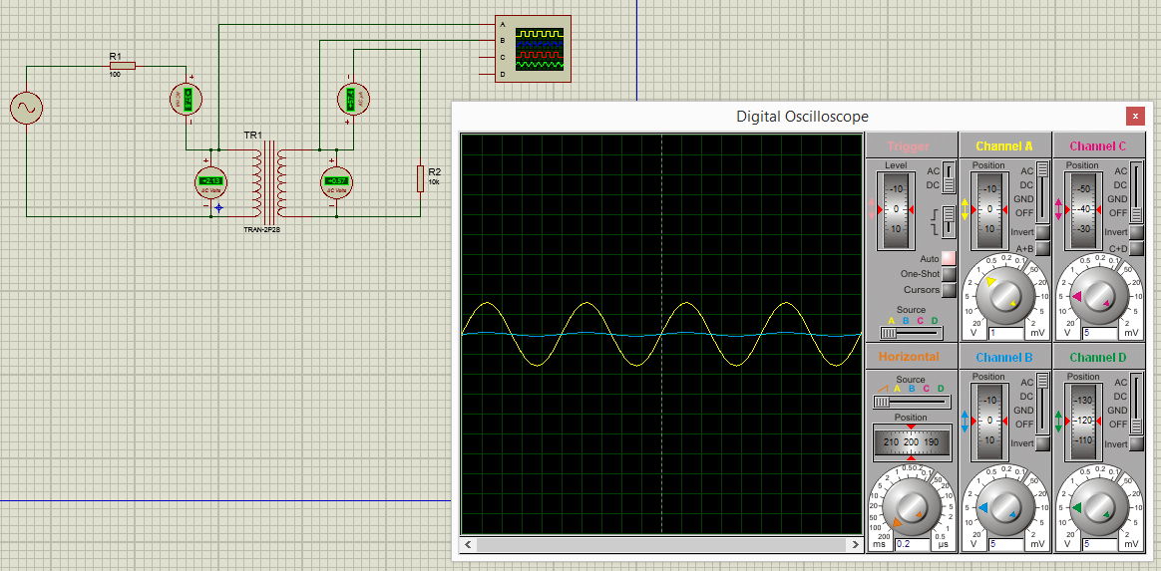

**A)**



**M= k (L1.L2)^1/2=1(20.2000)^1/2=200**

**f= 50 Hz , w=2.(3.14).(50)=314 rad/s**

**jwM=j62800**

**zL1=jwL1=j6280**

**zL2=jwL2=j628000**

**1: -311 0° + I1(100+j6280)-I2(j62800)=0**

**2: I2(10000+j628000)-I1(j6280)=0**

**2: I2(628079,61 89.09°)=I1(6280 90°)**

**I1=(100.01 -0.91°)I2**

**1: (6280.80 89.09°)(100.01 -0.91°)I2-(62800 90°)I2=311 0°**

**I2(628142.81 88.18° - 62800 90°)=311 0°**

**I2=55.01 -87.98° mA**

**I1=5.50 -88.98° A**

**V1= I1.zL1 = (5.50 -88.98°).(j6280)=34540 -1.02° V**

**V2=I2=zL2 = (55.01 -87.98° x 0.001).(j628000) = 34546.28 2.02° V**

**i1(t)=5.50 (cos 314t - 87.98) A**

**i2(t)=55.01 (cos 314t - 88.98) mA**

**v1(t)= 34540 (cos 314t - 1.02) V**

**v2(t)= 34546.28 (cos 314t - 2.02) V**

**B)**



**M=0.85(10.1)^1/2=2.69**

**w=2.(3.14).50=314 rad/s , f=50 Hz ,**

**zL1=jwL1=j3140**

**zL2=jwL2=j314**

**jwM=j844.66**

**1: -311 0° + I1(100+j3140)-I2(j314)=0**

**2: I2(10000+j314)-(j3140)I1=0**

**2: I2(10481.39 17.43°)=I1(3140 90°)**

**I1=(3.34 -72.57°) I2**

**1: (100+j3140).(3.34 -72.57°)I2 - (j314)I2=311 0°**

**(3141.59 88.18°)(3.34 -72.57°)I2 - (j314)I2=311 0°**

**(10492.91 15.61°)I2 - (j314)I2=311 0°**

**(10105.89 + j2509.52)I2=311 0° => (10412.81 13.95°)I2=311 0°**

**I2=29.87 -13.95° mA**

**I1=(3.34 -72.57°)(29.87 -13.95° x 0.001) = 99.77 -86.52° mA**

**V1= I1.zL1=(99.77 -86.52° x 0.001).(j3140) = 313.28 3.48° V**

**V2= I2.zL2=(29.87 -13.95° x 0.001).(j314)=9.38 76.05° V**

**i1(t)= 99.77 (cos 314t - 86.52) mA**

**i2(t)= 29.87 (cos 314t - 13.95) mA**

**v1(t)= 313.28 (cos 314t+3.48) V**

**v2(t)= 9.38 (cos 314t + 76.05) V**